Pickleball Ireland Equality Diversity & Inclusion

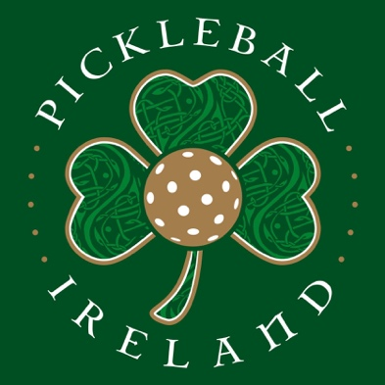

An Introduction

One of the main aims of Pickle Ball Ireland is to enable more people to play and support pickleball more often, growing and sustaining the sport so that it is safe, inclusive, fair and accessible.
As we work towards this, we are committed to promoting safe and inclusive pickleball, so that people have positive experiences of our sport which we aim, to be available to everyone.
As a relatively new sport we are very aware to ensure in all we do that diversity and inclusion remains our core focus and the involvement from many different backgrounds whether as a player, coach, official, an employee or as a volunteer are vitally important.
This applies at all levels of the sport and a key aim in support of this is ensuring that we achieve the highest level of the Equality Standard for Sport.

Policy
This Policy therefore sets out our commitment and includes our Safe and Inclusive Standards, Codes of Conduct and Reporting Procedure and it supports our overall aims for diversity and inclusion so to ensure that Pickleball Ireland is and remains diverse and inclusive.

Equality, Diversity and Inclusion are embedded in our culture and our behaviours:

Create a culture where inclusive leadership thrives;
Take a proactive approach using positive action to ensure that individuals are valued and able to achieve their full potential;
A belief that everyone involved with Pickleball Ireland has a vital role to play in promoting diversity and inclusion and we ask everyone to become Safe and Inclusive pickleball Ambassadors – proactively promoting a Safe and Inclusive playing environment and taking action against all forms of discrimination.
We are proud to have a Diversity and Inclusion Policy, Safe and Inclusive Standards, Codes of Behaviour which demonstrate our commitment to making Pickleball Ireland diverse and inclusive.
We know we can make a positive difference to colleagues and players from different backgrounds within Pickleball Ireland and to people of all ages from different backgrounds – on the island of Ireland who participate in pickleball

Policy Statement

Pickleball Ireland’s Equality, Diversity and Inclusion Policy, Safe and Inclusive Standards, Codes of Conduct and Reporting Procedure are applicable to:

- Employees
- Players
- Coaches
- Board members
- Committee members
- Contractors
- Volunteers, and
- Anyone associated with Pickleball Ireland.

The primary aim is to ensure that all of the above can be open and safe both within the pickleball environment and to encourage more people to play, support, grow and sustain the sport so that it is inclusive and fair.

We wish to enhance the environment that provides for equal opportunities for all current, future and potential employees including those connected with the governance and promotion of the sport.

We also wish that the dignity of all participants at all times is protected and respected particularly employees and all members and Officers that maybe engaged in the future.

This applies to all regardless of age, disability, gender, marital or civil partnership status, pregnancy or maternity, race, sex, sexual orientation, religion, ethnicity or indeed any other background.

This applies also to all on the island of Ireland, regardless of religious belief, political opinion, racial group, age, marital status, sexual orientation, men and women generally, persons with a disability or persons without, and persons with dependants and persons without

Safe and Inclusive Standards

The aim is to set out a minimum level of practice to promote and support safeguarding, diversity and inclusion within Pickleball Ireland setting a series of minimum standards to be used alongside this policy and that of the Code of Conduct.

.
Standard 1

Ensure the existence of an Equality, Diversity and Inclusion Policy and a Codes of Conduct that applies and is followed by all employees, consultants, coaches, officials and volunteers.
All policies and related procedures will be risk assessed, monitored and updated on a regular basis.

Standard 2

Commitment where applicable, to inclusive recruitment, induction, training and support.
Where applicable all applications, interviews and references address safeguarding, diversity and inclusion requirements and attitudes.to be respected.
All eligible employees, consultants, volunteers, accredited officials and coaches have a Garda Vetting check or Access NI Vetting check as required.

Standard 3

Protect at all times all personal and confidential information.

